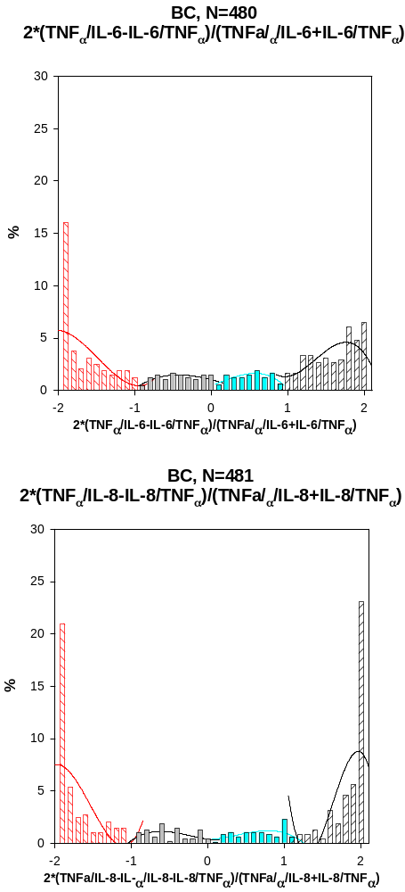
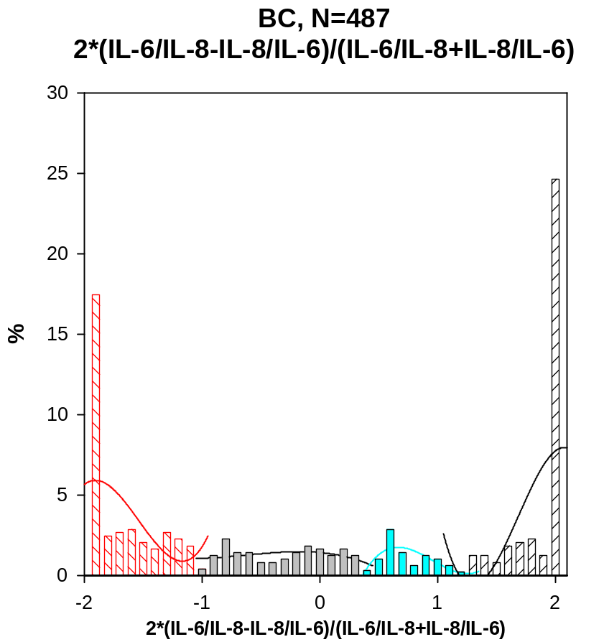

 | Type 1 | Type 2 | Type 3 | Type 4
2*(TNF/IL-6-IL-6/TNF)/(TNF/IL-6-IL-6/TNF) | [-2; -0.9] | [-0.9; 0.1] | [0.1; 0.9] | [0.9; 2]
2*(TNF/IL-8-IL-8/TNF)/(TNF/IL-8+IL-8/TNF) | [-2; -0.9] | [-0.9; 0.1] | [0.1; 1.1] | [1.1; 2]
2*(IL-6/IL-8-IL-8/IL-6)/(IL-6/IL-8+IL-8/IL-6) | [-2; -1] | [-1; 0.4] | [0.4; 1.2] | [1.2; 2]

